Sample selection criteria:
- Excluded rows containing missing values in credit history information.
- Excluded rows containing missing values in gender information.
- Excluded rows containing missing values in marriage status information.

Overall descriptive statistics summary of the data set:
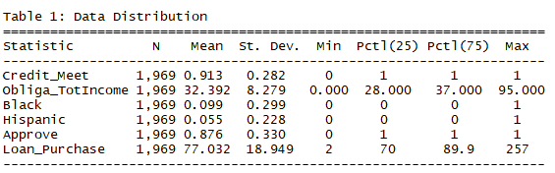

Obligations total income descriptive statistics by race:
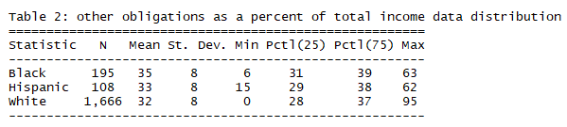

Loan-purchase percentage descriptive statistics by race:
